

**Memory Skills Workbook  
Session 4: Internal Memory Enhancement Strategies**

**Course Overview**

Session 1 Introductions and an overview of cognitive abilities

Session 2 Overview of memory

Session 3 External memory enhancement strategies

**Session 4 Internal memory enhancement strategies**

Session 5 Mood and cognitive functioning

Session 6 Keeping well, course reviews and goodbyes

**Introduction**

Internal memory enhancement strategies are strategies that we use within our minds to aid memory. These strategies focus on different parts of the process of memory, including encoding, storage and retrieval and can be useful for remembering new information. Today we will be talking a bit about these strategies. But to start off the session, we will be introducing mindfulness – an approach that can be useful for lots of different things, including memory and wellbeing.

**Mindfulness**

Our minds often wander and life is sometimes filled with stresses or worries. To start off today, and at the beginning of our future sessions, we will carry out a brief breathing exercise. The aim of this is just to help us be more present ‘in the moment’, and give us some time to become more aware of our thoughts, feelings and any physical sensations.

[](http://www.google.co.uk/url?sa=i&rct=j&q=&esrc=s&source=images&cd=&cad=rja&uact=8&ved=0ahUKEwjorp63uOjVAhXIuhQKHfsDC90QjRwIBw&url=http://sgpsychology.co.za/progressive-muscle-relaxation/&psig=AFQjCNGODeAsdYOGDfoI8pmdahueUX_IHw&ust=1503408816904714)

**Mindfulness Exercise:** Track 3 on CD

**Internal Memory Enhancement Strategies**

As we’ve said, internal memory enhancement strategies are strategies that we use within our minds to aid memory.

An outline of some of these strategies is provided below.

**Brain Exercise**

Keeping our brains active is very important for ensuring our minds stay healthy by training and keeping the pathways in the brain active. This might include doing crosswords, Sudoku, puzzles and arithmetic.

**Chunking of Information**

Rather than trying to remember a whole phone number or list such as 1485968704, chunk the numbers into 148-596-8704.

[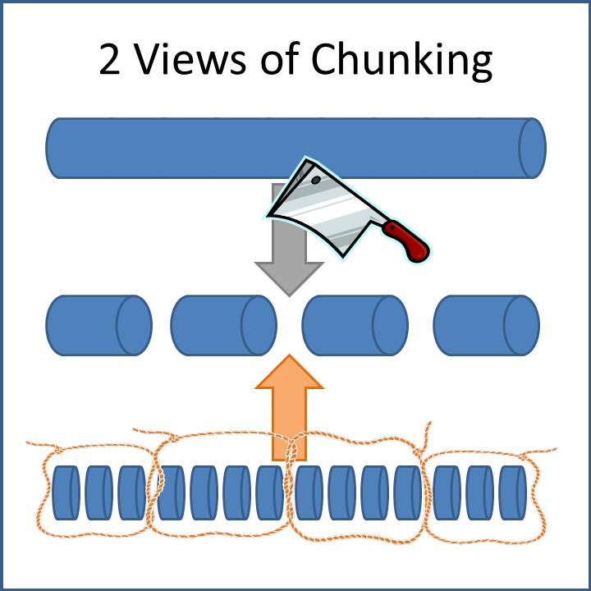](http://www.google.co.uk/url?sa=i&rct=j&q=&esrc=s&source=images&cd=&cad=rja&uact=8&ved=0ahUKEwju1e-XlObWAhUQK1AKHeE2BB0QjRwIBw&url=http://presentationswithresults.com/are-you-chunking-your-content/&psig=AOvVaw3xD09P6r6OaiKwSfEQ20eu&ust=1507728384029746)

**Repetition**

When trying to encode information into you memory, rehearse it.

You can do this by either repeating it out loud or in your head.

[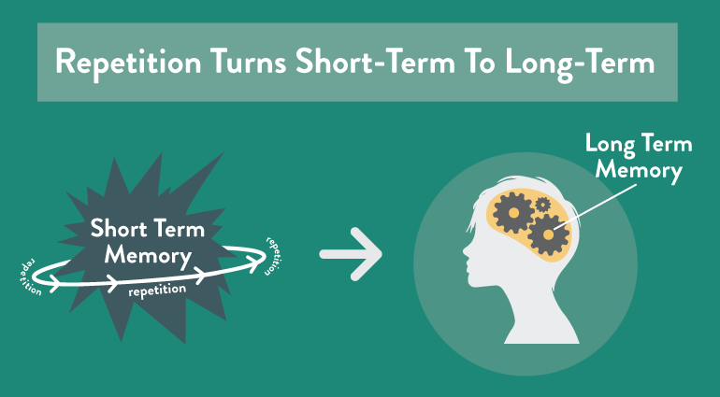](https://www.google.co.uk/url?sa=i&rct=j&q=&esrc=s&source=images&cd=&cad=rja&uact=8&ved=0ahUKEwiF8MHTxOjVAhVESRoKHfC5CqAQjRwIBw&url=https://coschedule.com/blog/memory-techniques/&psig=AFQjCNGBWrZ2SyE5KsUv01gZZ9DqDgeDsQ&ust=1503412095760996)

**Grouping**

Grouping information together into categories can aid recall because it makes information more meaningful. For example, if you need to remember a shopping list it might be useful to group items into fruits, vegetables etc.

**Breaking down tasks**

When learning how to do something new it can be helpful to plan and break the task down into smaller steps. Write these steps down so you can refer back to them next time you do that task. For example, if learning how to cook a new dish you might break down the task into smaller sections; write a checklist of all the ingredients I need, write a list of all the utensils I need, take out the ingredients, take out the utensils, turn on the oven etc. This will help you to attend to each aspect of the task and consolidate learning.

**The PQRST method**

The PQRST method is used to help improve our memory for information that we read. Reading is usually quite a passive way of learning but PQRST helps us to remember better by making the process more active.

Each letter stands for a different stage in this process:

**P stands for PREVIEW:** You should preview the text that you are going to read by quickly skimming through it. This will help you to get an idea of what the text is about.

**Q stands for QUESTION:** Next you should ask yourself questions about the text. E.g What is it about? Who are the main characters? What am I supposed to learn from this? You can write these down if needed.

**R stands for READ:** Read the text, keeping the questions you asked yourself in mind. This will help you focus on the most important areas.

**S stands for SUMMARY:** Summarise the key points of the text. Ask yourself what was it about? Did it make sense to you? Do I need to reread anything?

**T stands for TEST:** Test your knowledge of it, you can do this by asking yourself the questions you thought of earlier and see if you’re better able to answer them now. This will help you to consolidate the information.

**Making Associations**

Making associations between something you need to remember and previous knowledge can help us to make the new information more meaningful and we therefore remember it better. This includes:

* Remembering to do a new activity by linking it to an existing one. For example, taking medication at meal times
* Learning a new name by associating it with something or someone you already know. For example, you might remember the name Angela by thinking of an angel.
* Leaving an item associated with an activity visible so you remember to do it. E.g. leaving the boots by the door so you remember to take the dog for a walk.

[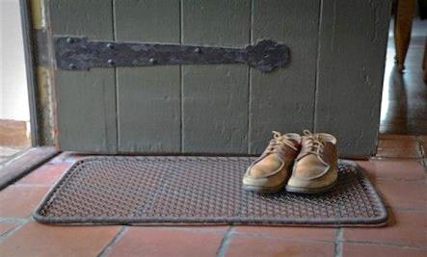](https://www.google.co.uk/url?sa=i&rct=j&q=&esrc=s&source=images&cd=&cad=rja&uact=8&ved=0ahUKEwig3o3nyOjVAhXGOxQKHRhIDFUQjRwIBw&url=https://livehealthyosu.com/2016/04/07/leave-your-shoes-at-the-door-please/&psig=AFQjCNEj7Aq59PNaD6VP_w-a9ilBomf4tA&ust=1503413159684485)

**Mental Retracing**

If we’re struggling to remember something, retracing our movements, activities and thoughts in our heads can be helpful.

**Stories**

Making up stories can be useful for remembering things. For example, if you had a shopping list of weetabix, milk, jam, teabags and toothpaste you might create a story like ‘In the morning I get up and have my Weetabix with milk and jam then I have a nice cup of tea before I brush my teeth’.

[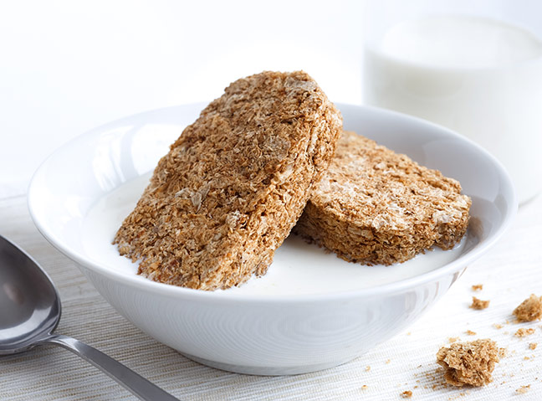](http://www.google.co.uk/url?sa=i&rct=j&q=&esrc=s&source=images&cd=&cad=rja&uact=8&ved=0ahUKEwi8yK2gy-jVAhXIxxQKHV-SDbYQjRwIBw&url=http://www.womanandhome.com/news-and-entertainment/541944/supermarket-own-brand-weetabix-ludicrously-similar-to-branded-product&psig=AFQjCNFM6EGnX9pNPbi9coSONwxAySPECg&ust=1503413851895471)

**Visual Imagery**

The use of visual imagery can be very helpful for learning and remembering information. Below are some examples:

* **Things to do -** If you need to complete a task like posting a letter, you can imagine yourself doing that task. By making the association between the post-box and the action of posting the letter you’re more likely to remember to do it.
* **Routes –** If you need to remember a new route it can be useful imagining yourself walking the route.
* **Peg Method**

**Peg Method**

This method uses two memory strategies to help you remember information. It uses **‘association**’ and **‘visualisation’**.

The idea is that you will ‘hang’ one piece of information on each peg.

Following the steps below to set up your pegs:

1. Number your pegs in order, e.g. 1 2 3 4
2. Write down a word that rhymes with each number. This works best if the word can be easily pictured in your mind, e.g. two = shoe

One: ____________   
  
Two: ____________

Three: ____________

Four: ____________

1. What does each word look like as a picture in your mind, e.g. is it cartoon, is it colour, how big is it? Can you draw this in the box?
2. Repeat the paired numbers/words aloud until you feel confident with them
3. Repeat the paired numbers/words in your head and as you do this, visualise the words as pictures in your mind
4. Imagine you need to remember to phone a friend later today. Use your imagination to associate a visual image of phoning a friend, with the visual image of peg one.

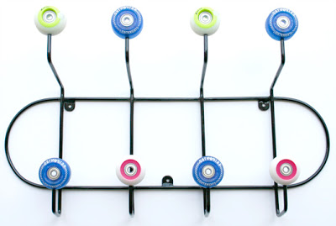

**Useful Internal Strategies for each stage of the Process of Learning and Remembering.**

|  |  |
| --- | --- |
| **Stage** | **Strategies** |
| **Attention** | * Mindfulness meditation * Breaking down tasks * Making associations * Visual imagery * Peg method |
| **Information processing** | * Making associations * Visual imagery |
| **Encoding and storage** | * Chunking * Grouping * PQRST * Repetition * Expanding rehearsal * Making associations * Stories * Visual imagery * Peg method |
| **Retrieval** | * Mindfulness meditation * Mental retracing * Making associations * Replacing numbers * Visual imagery |

**Out of session work – putting together my memory strategy ‘toolbox’**

Complete the flowchart below page to identify which internal strategy might be helpful for you. Remember it takes time for strategies to work and different strategies work for different people.

work for different people.

1. Choose one memory difficulty that you would like to focus on:

*It might be useful to look over the memory strategy sheet you completed after session 1.*

I would like to focus on: __________________________________________________

**2.** Which part of the memory process might be causing this difficulty?  
*It might be useful to look over the memory self-assessment 2 sheet you completed after session 2.*

My main area of difficulty is: ______________________________________________

**3.** What are my cognitive strengths?   
*You might want to look over memory assessment form 2 for this.*

My strengths are: _______________________________________________________  
  
_____________________________________________________________________

____

4. Choose a strategy that we discussed today that might help with your difficulty.

*Try out this strategy over the next week and we will discuss how it went over the next week.*

External memory enhancement strategy: ____________________________________

**Out of session work – implementing my internal memory enhancement strategy**

Between now and the next session we would like you to start implementing the strategy that you have chosen.

Again, it’s important to remember that it takes time for strategies to start working so we should try not to have expectations about the effectiveness of the strategy.

|  |
| --- |
| Use the space below to write notes if needed: |
|  |
|  |
|  |
|  |
|  |
|  |
|  |
|  |
|  |
|  |
|  |
|  |
|  |
|  |
|  |
|  |
|  |
|  |
|  |